Project

Restaurant Wheel

**A MINI PROJECT REPORT**

***Submitted by:***

***AKSHAT AGGARWAL (2110990122)***

***in partial fulfillment for the award of the degree of***

**BACHELOR OF ENGINEERING**

***in***

**COMPUTER SCIENCE & ENGINEERING**



**CHITKARA UNIVERSITY**

***RAJPURA PUNJAB (140401)***

TABLE OF CONTENT:

|  |  |  |
| --- | --- | --- |
| **SR.** | **TOPIC** | **PAGE NO.** |

|  |  |  |
| --- | --- | --- |
|  |  |  |
| **1.** | **INTRODUCTION** | **3** |
|  |  | |
| **3.** | **TECHNICAL DETAILS** | **5** |
| **4.** | **KEY FEATURE** | **6** |
| **5.** | **HIGHLIGHTS** | **7** |
| **6.** | **CONCLUSION** | **8** |
| **7.** | **REFERENCES** | **9** |

# Introduction:

A restaurant website is a business website that **aims** to provide information on their menu, service, location, and other services. It also provides directions to the restaurant.

It may also offer promotional discounts and special offers from the restaurants along with recipes created by chefs. The goal of a restaurant website is to help consumers find an establishment that best fits their needs.

I’m sure you’ve been asking yourself the same question: what is a restaurant website? This post answers this very question for you in detail while providing tips for creating your own easily manageable site.

Food is an important aspect of our lives, however, most people would disagree with that statement. Personally, I think food is one of the crucial elements that bring us together as humans. It provides us with calories to survive and taste buds to enjoy.

Since food has a significant impact on our lives, it only makes sense as to why restaurants are so popular these days. Restaurants have been around for centuries dating back to Roman times when they were open-air stalls selling bread and other edibles.

.

# Technical Details:

* **HTML** is the standard markup language used to create web pages. It is essential to ensure that the HTML code is clean and valid, including using proper headings, meta tags, and structured data. This helps search engines understand the content of the web pages and index them properly.
* **CSS** is used to style the web page and make it visually appealing to users. While CSS does not have a direct impact on SEO, it can indirectly affect the user experience. A well- designed website that is visually appealing and easy to navigate can improves the user experience.
* **JavaScript** is a programming language used to add interactivity and dynamic content to web pages. It can be used to create animations, pop-ups, and other interactive elements that can enhance the user experience.
* A **responsive** design that works well on different screen sizes and devices is essential for SEO as mobile traffic continues to increase.
* A fast-responding website is crucial for SEO. You can **improve page speed** by optimizing images, minifying code, and leveraging caching.
* **A well-structured URL** that includes the target keyword can help search engines understand the content of the page.
* The **meta** title and description accurately describe the content of the page and include the target keyword
* **Linking** to other relevant pages on your site can help search engines understand the context of your content and improve the user experience.

# Key Feature:

* HOME MADE FOOD : The survey form covers a wide range of university facilities, including study spaces, sports and recreational facilities, laboratories, technology resources, dining services, health and wellness facilities, transportation, and more. This comprehensive approach ensures that all important aspects of university facilities are addressed.
* DAILY MENU CHANGE: The survey form includes rating scales or satisfaction metrics to measure respondents' level of satisfaction with different facilities. This allows for

quantitative analysis and comparison of satisfaction levels across various facilities, helping identify areas of improvement or areas that are performing well.

* EASY ORDERING: The survey form includes specific questions to gather feedback on each facility or facility category individually. This enables targeted analysis and actionable insights for each area, ensuring that feedback is focused and relevant.
* EASY CANCELATION: The survey form includes questions that require respondents to rank facilities or facility features based on their importance or priority. This feature helps in understanding the relative significance of different facilities to students, guiding decision-making and resource allocation processes.
* DISCOUNT OFFERS: The survey form includes questions that assess the availability and capacity of different facilities. This information helps in identifying potential overcrowding or underutilization issues, allowing for better planning and allocation of resources.
* SNACK ORDERING: The survey form incorporates open-ended questions to gather qualitative feedback from respondents. This enables participants to provide detailed suggestions, comments, and specific examples, offering valuable insights into their experiences and potential areas for improvement.

# HIGHLIGHTS:

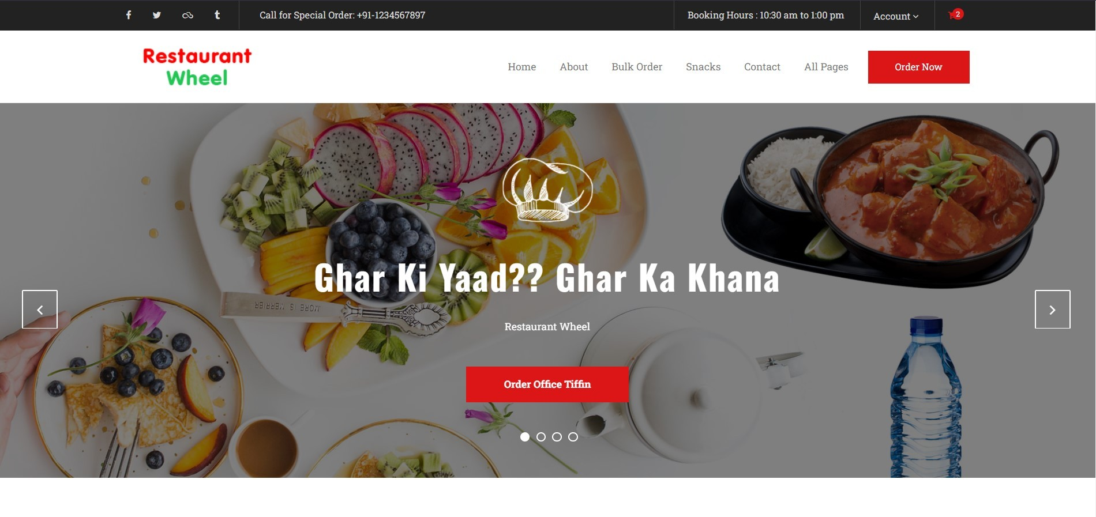

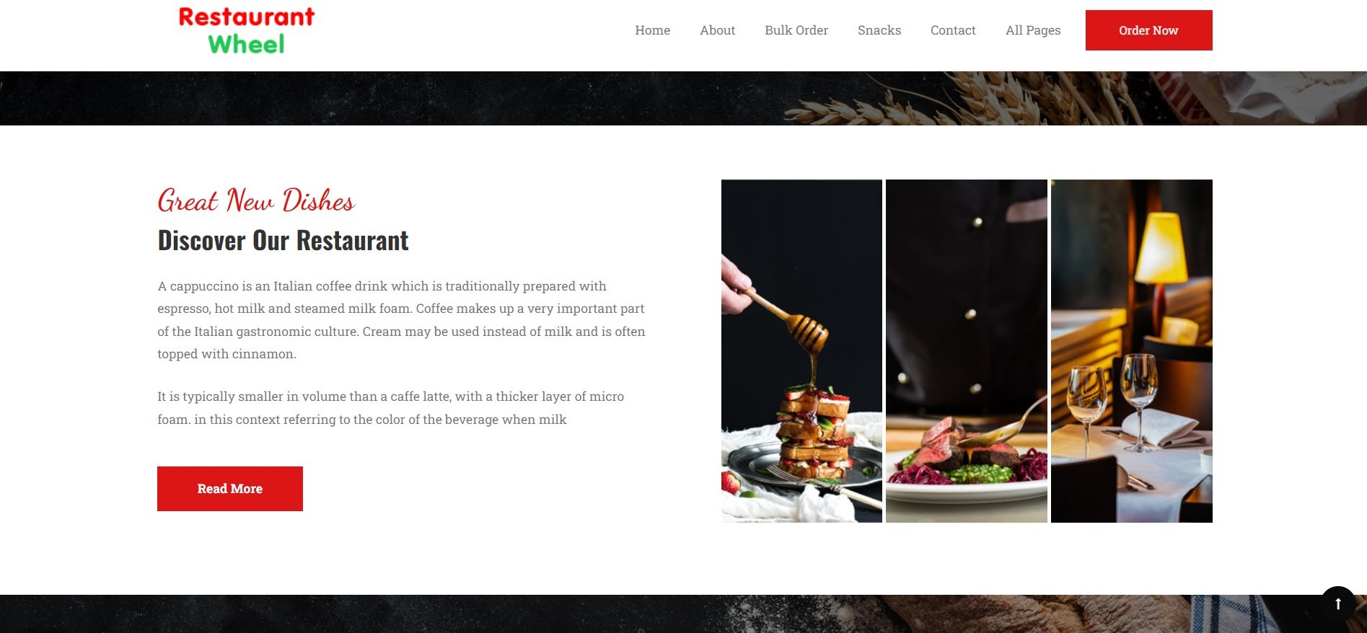

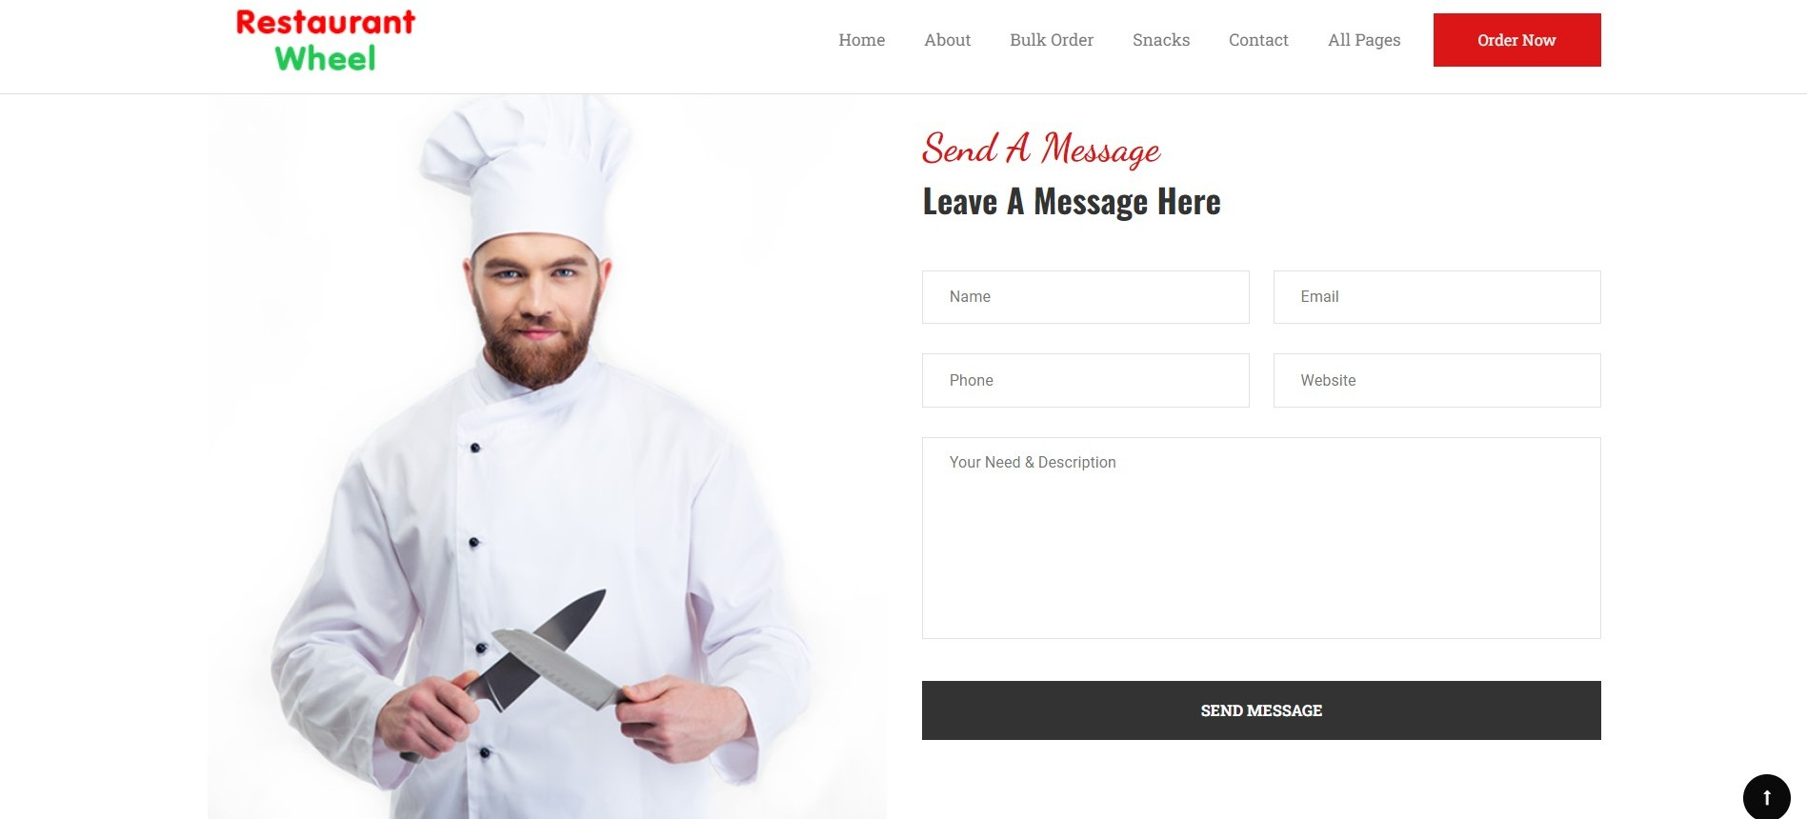

**Code Screenshots:**

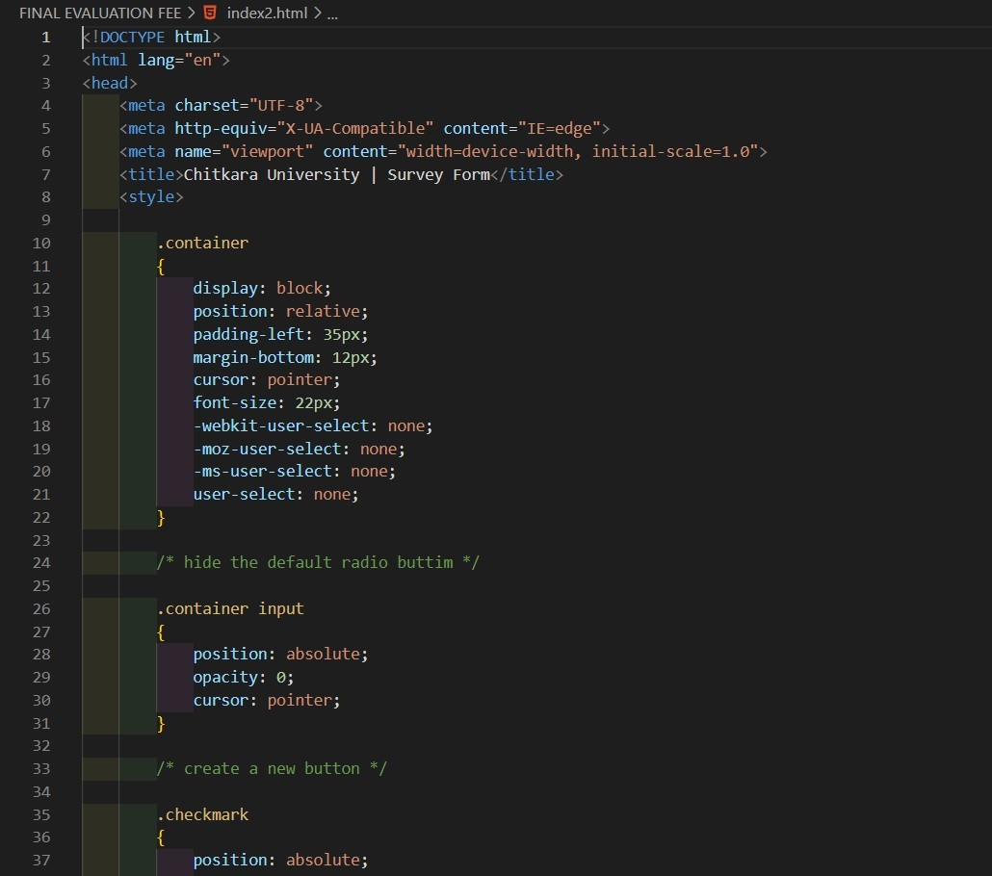

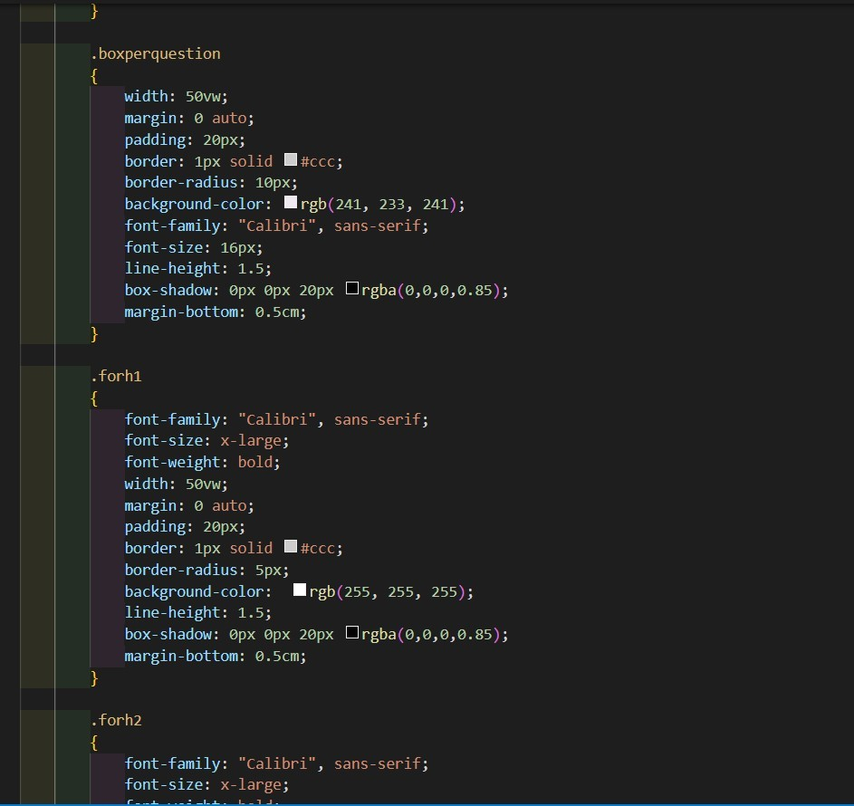

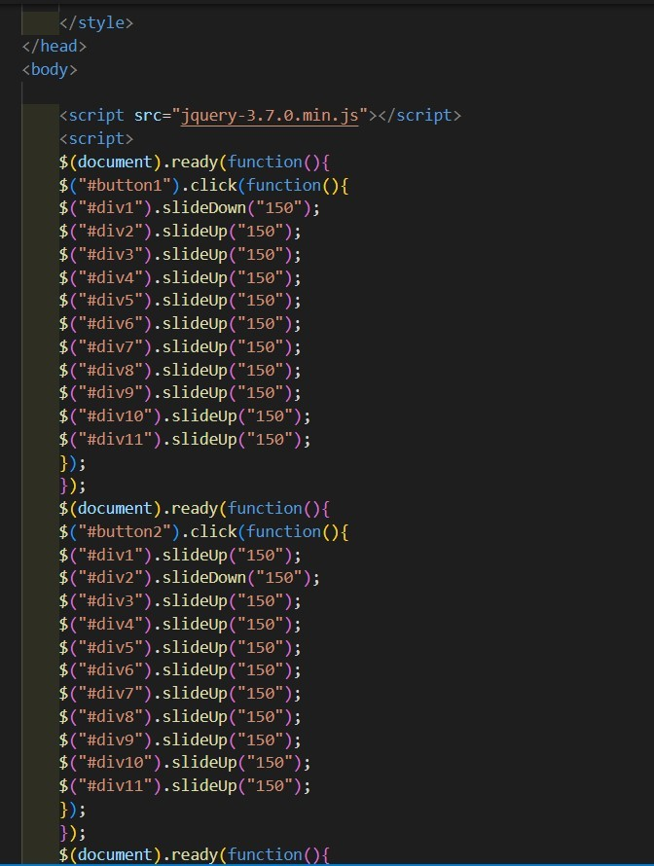

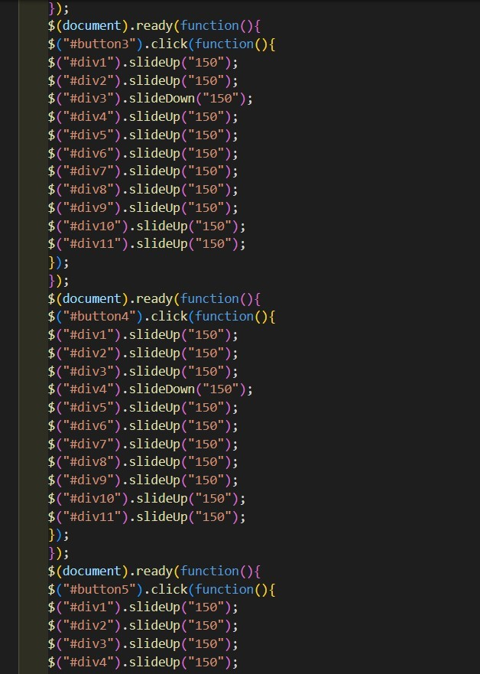

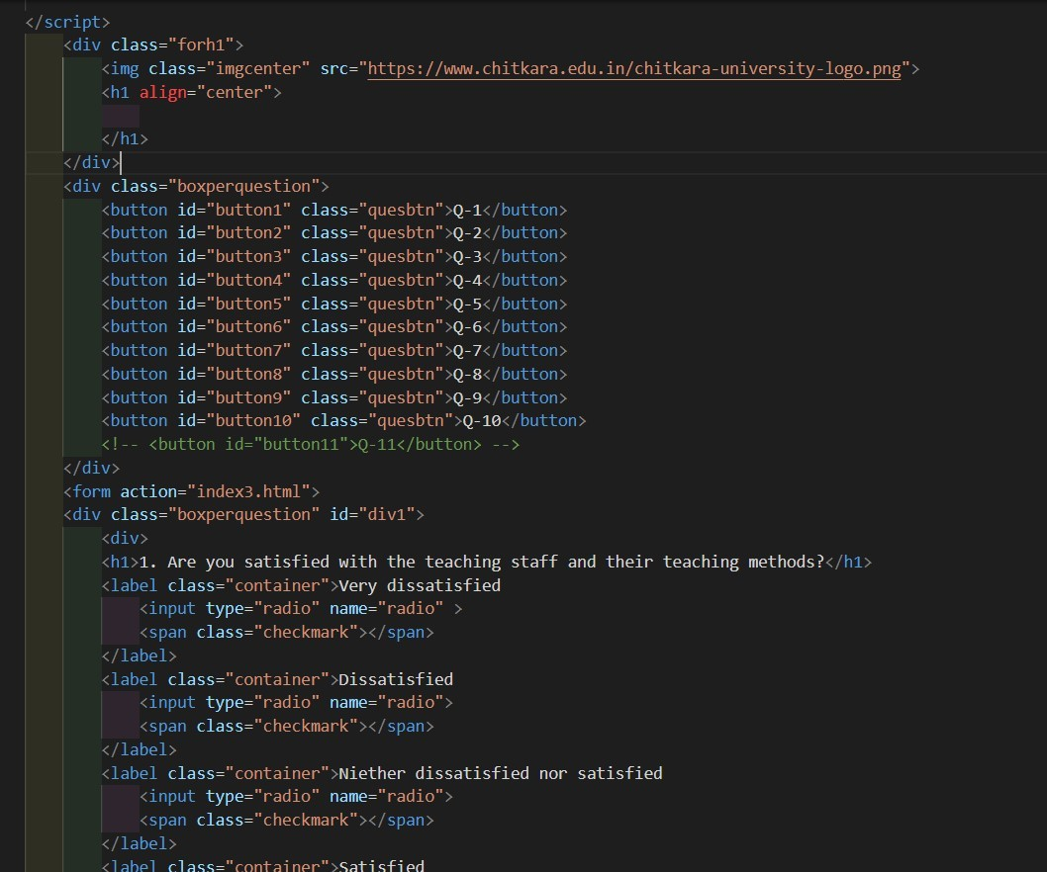

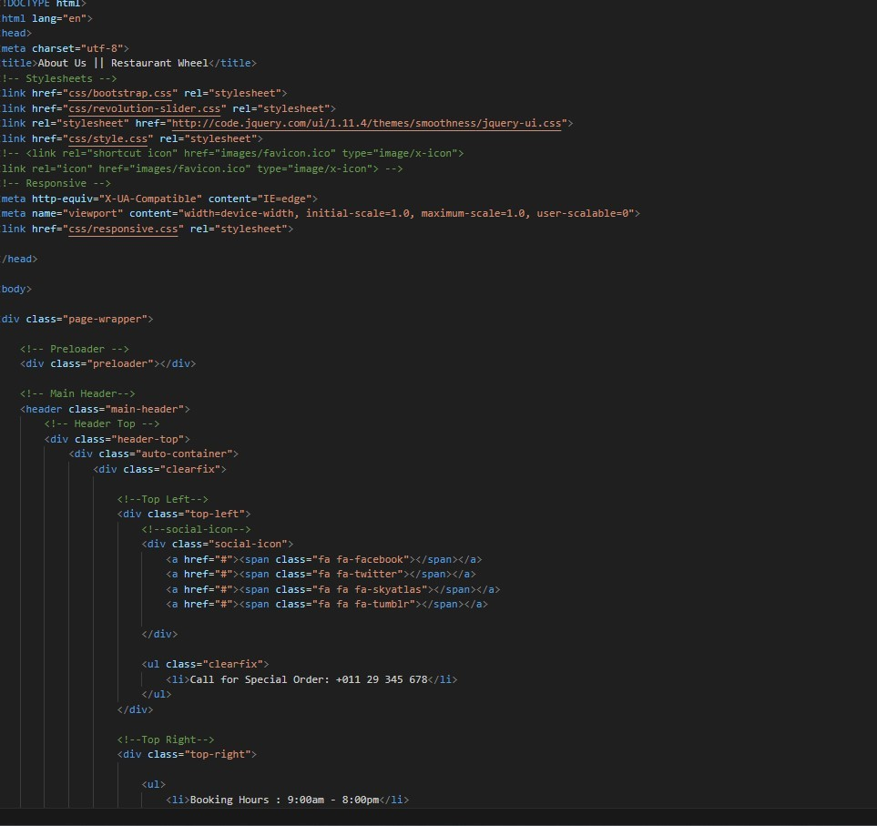

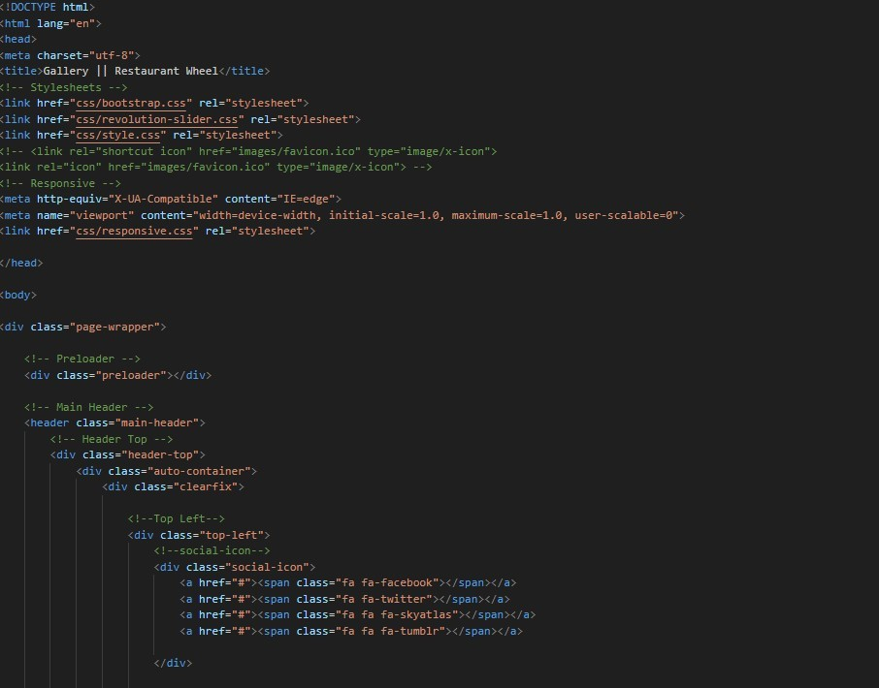

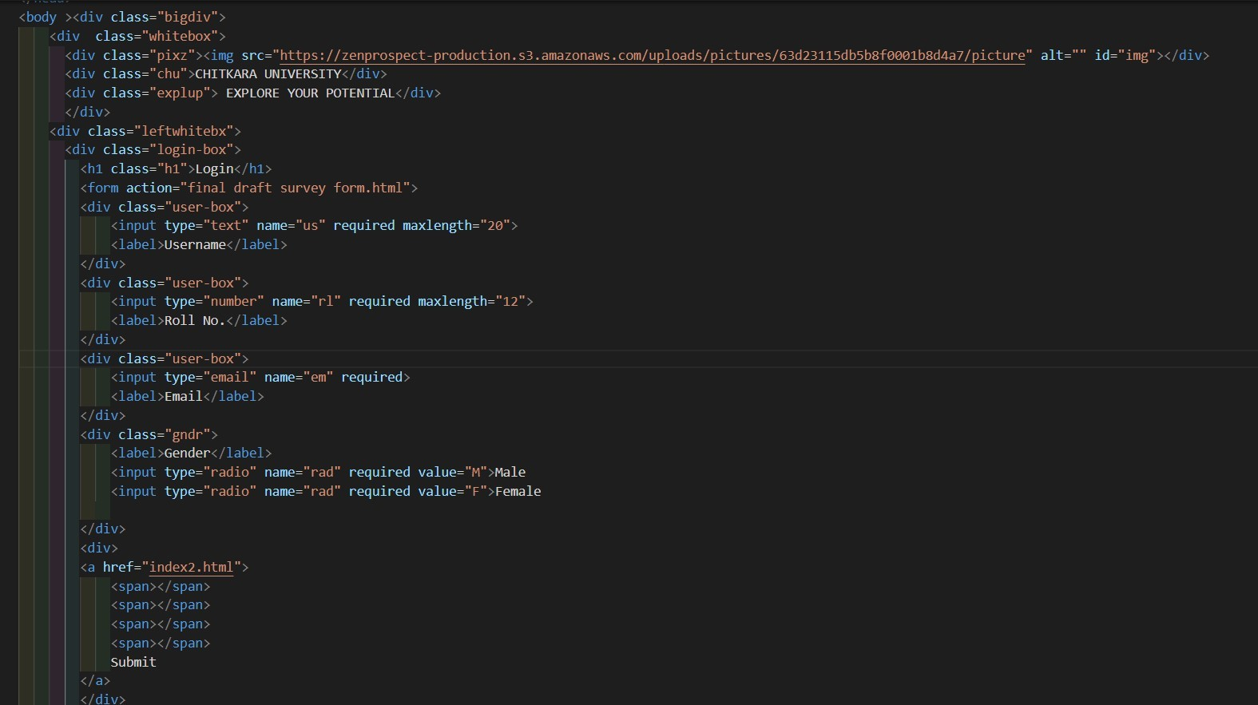



# Conclusion:

* In conclusion, the survey form has proven to be an effective tool for gathering valuable insights and feedback from respondents. It has provided a comprehensive understanding of the opinions, preferences, and experiences of the participants on the specific subject matter.
* Through the survey form, we have been able to collect a significant amount of data, allowing us to analyze trends, identify patterns, and draw meaningful conclusions. The responses received have provided us with a wealth of information that can be used to make informed decisions, develop strategies, and drive improvements.
* Moreover, the survey form has allowed us to engage directly with our target audience, giving them a platform to voice their opinions and share their experiences. This two-way communication fosters a sense of inclusivity and ensures that the perspectives of the respondents are heard and considered.
* The survey form has not only provided us with quantitative data through multiple-choice questions but has also offered qualitative insights through open-ended questions. This qualitative feedback has provided valuable context and deeper understanding, allowing us to delve into the reasoning behind respondents' choices and opinions.
* Furthermore, the survey form has proven to be a convenient and efficient method of data collection. It has allowed us to reach a wide audience and gather responses from diverse individuals, thereby increasing the representativeness of the data. The flexibility of the survey form also enables us to tailor questions to specific areas of interest, ensuring that we collect data that is relevant and meaningful.
* In summary, the survey form has been a valuable tool for gathering feedback and insights. It has provided us with a comprehensive understanding of the subject matter and has empowered us to make data-driven decisions. Moving forward, the information collected through the survey form will serve as a foundation for further analysis, planning, and improvement in the relevant areas. We are grateful to all the respondents who took the time to participate in the survey, as their contributions have been instrumental in shaping our understanding and future actions.

**References:**

* https://[www.w3schools.com/](http://www.w3schools.com/)
* https://stackoverflow.com/
* https://[www.geeksforgeeks.org/](http://www.geeksforgeeks.org/)
* HTML and CSS: Design and Build Websites
* Learning Web Design: A Beginner's Guide to HTML, CSS, JavaScript, and Web Graphics